Oct. 15, 2015
CONTACT: Bob Stronach, OFS, 315-796-9468; Mary Stronach, OFS, 315-796-9284; stronach@kateriregion.org

Sr. Caritas Honored at National Chapter in New Jersey
African Nun Who Founded Orphanage Receives
U.S. Franciscan Peace and Justice Award
Sister Caritas Barajingitwa, LSOSF, dreamed of providing a loving home and practical education for orphans in Africa. With the help of American donations, that dream came true when she opened Holy Family Vocational Orphanage in Southern Uganda.
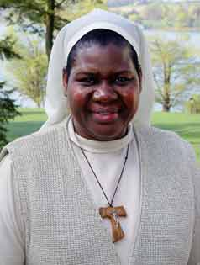
For her work, the U.S. Secular Franciscan Order, meeting in national chapter in Clinton, NJ, Oct. 13-18, honored Sister Caritas with the Franciscan Justice, Peace and Integrity of Creation (JPIC) Award.
JPIC Commission Chair Carolyn Townes, OFS, introduced Sister Caritas, citing her for creating a future for children of AIDS victims.
The award includes a $2,500 prize.
The money is enough to pay the orphanage’s bills for several months, said Sister Caritas, a member of the African-based Little Sisters of St. Francis.
The orphanage houses 18 children, and includes 13 acres for farming plus 13 acres for future dormitories and a new school, eventually to accommodate 100 children.
Sister Caritas got the idea for the orphanage while pursuing a master’s degree in education in the late 1990s at McGill University in Montreal, Quebec. In fact, the idea became her master’s thesis, she said.
“Going back to Uganda, I thought it would be just a matter of putting the project into place,” she recalled. “I went door to door begging, to no avail.”
But God opened another door, as she would put it.
The pastor of St. Mary of the Assumption Church in Binghamton, NY wrote a letter to the mother superior of the Little Sisters, asking her to send one of her sisters to work in his parish. The mother superior summoned Sister Caritas and told her she was going to the United States. She arrived in June 2001. Two years later, thanks to donations by American Catholics, she was able to open Holy Family Vocational Orphanage and welcome the children into its protection.
Secular Franciscans and other friends in Binghamton established the Holy Family Vocational Orphanage Foundation to continue raising funds for the orphanage and further Sister Caritas’ dream.
A proponent of teaching practical life skills as well as academics, Sister Caritas said the orphanage teaches home economics, carpentry, basket weaving, sewing and tailoring, and farming and animal husbandry.
However, sister noted, for the orphans, “knowing that they are loved is most important” because “then they will be able to love others.”
###

